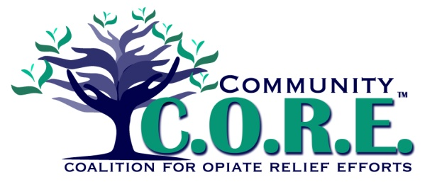

Youth Council Application 2017-18

Name:__________________________________________ Grade:_____________

School District:__________________________________ County:____________
PERSONAL INFORMATION
Address:_________________________________________________________________
Phone Number: ___________________________ Does this number receive texts? YES NO
Email Address: ___________________________ Do you use Facebook? YES NO Twitter? YES NO
EMERGENCY CONTACT INFORMATION

Emergency Contact Person 1:
Name__________________ Relationship to you________________ Phone Number___________
Emergency Contact Person 2:
Name__________________ Relationship to you________________ Phone Number___________
Emergency Contact Person 3:
Name__________________ Relationship to you________________ Phone Number___________

CONSENT TO PARTICIPATE

I hereby give my consent for my child _________________________ to participate in the C.O.R.E. Youth Council. This will require my child to attend a monthly evening meeting and occasionally local events. I will not hold C.O.R.E., the Mental Health Drug and Alcohol Services Board of Logan & Champaign Counties or any volunteers responsible for any accidents or injuries that may occur to my child while participating in meetings or events.

_______________________ ______________________________________ ______________________
Parent Printed Name Parent Signature Date

_______________________ ______________________________________ ______________________
Student Printed Name Student Signature Date

TELL US ABOUT YOURSELF

Please answer the following questions in the space provided. If you need more space, please use additional paper and number your responses. These questions will help us select the initial membership for the council.

- What interests you in becoming a member of the C.O.R.E. Youth Council?

- What is your story, what brings you to this team to help (use the lead in sentence to get started)?
Substance abuse prevention is important to me because…

- Do you work better in a team environment or by yourself? Are you a leader or a follower? What makes you say that?

- What do you do to help others in your family, neighborhood, school, or community?

- What do you do when you are stressed out - how do you de-stress?

Completed applications can be sent with the subject: Youth Council to slogwood@mhdas.org; faxed to 937-465-3914; or mailed to the MHDAS Board, PO Box 765, West Liberty, OH 43357. Applications are due by September 8th, 2017.

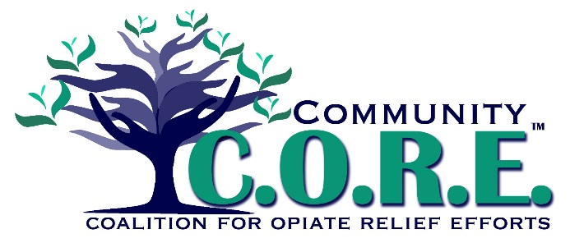
Mission Statement:
To develop and implement a multi-faceted plan, through collective partnerships that focus on prevention, treatment and long term recovery, in an effort to reduce misuse of prescription drugs and the use of illegal opiates among citizens of Logan County.
C.O.R.E. Values & Principles
1. Addiction is a disease--- it is not a character flaw.
2. Treatment works. People can and do recover and thrive again after addiction.
3. Every life has value.
4. Collaboration between recovering individuals, family members, community members, churches, funding entities, employers, medical practitioners, public health, child welfare, education, treatment providers, courts, law enforcement and legislative law makers is necessary to achieve the goal of reducing opiate abuse in Logan County.
5. The use of evidence based practices in the prevention, assessment, intervention and treatment of addiction is vital.
6. The link between misuse of Rx opiates and heroin is significant.
7. Multiple doses of prevention over one’s lifetime provides the most effective prevention for future drug abuse.
Vision Statement:
A healthy Logan County free of the devastating impacts of prescription drug and opiate abuse.
PREVENTION/EDUCATION TEAM and YOUTH COUNCIL CONTACT:
Stacey Logwood, slogwood@mhdas.org 937-465-1045

