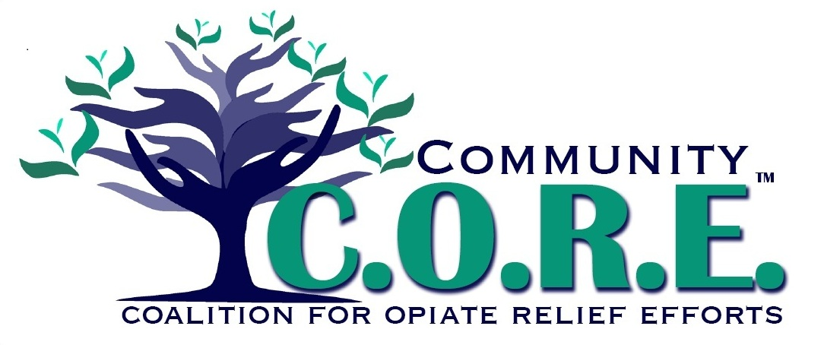

TO: Indian Lake Middle School Co-Principals:
Mr. Don Bauer and Mrs. Missy Mefford

FROM: Prevention Education Team of C.O.R.E.

RE: Trending Student Substance Abuse Activity (Ohio)

DATE: March 28, 2018

Hello,

We recently attended a Coalitions Rising: Policies and Practices for Better Prevention Conference in Columbus and wanted to share some information with you on a trending student substance abuse concern in Ohio. Please see the enclosures & feel free to make copies to share with staff and/or parents. If you prefer, you can take images of the materials and post on social media to disseminate.

If you have any questions or need anything, please do not hesitate to reach out to us.

On behalf of the Prevention/Education Team,

Co-Chair Stacey Logwood
slogwood@mhdas.org
937-465-1045

Co-Chair Ceci Yelton
cyelton@ccibhp.com
937-599-1975

