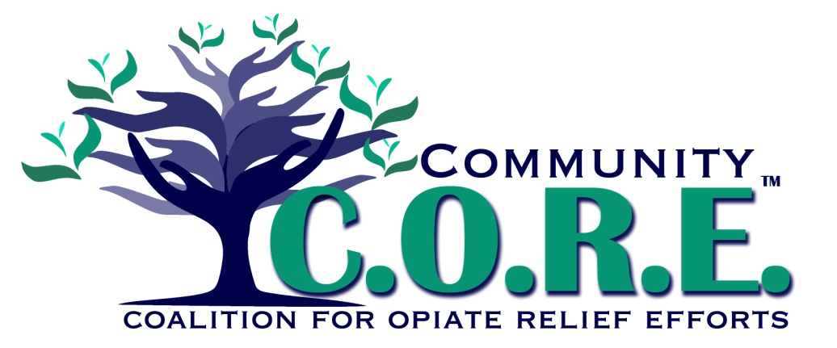**Legal Action Team**

No or limited court-centric services

**Access to Treatment for Drug Court Participants**

MAT is not consistent for eligible participants

**Opiate abuse is negatively impacting Logan County**

Criminal justice involved lack appropriate life skills

**Problem**

**Limited Social Support Services**

No one stop shop for entrance to services

**Local Conditions**

Info is not shared between court systems (inconsistent record systems)

Limited access to case management

**Risk Factors**