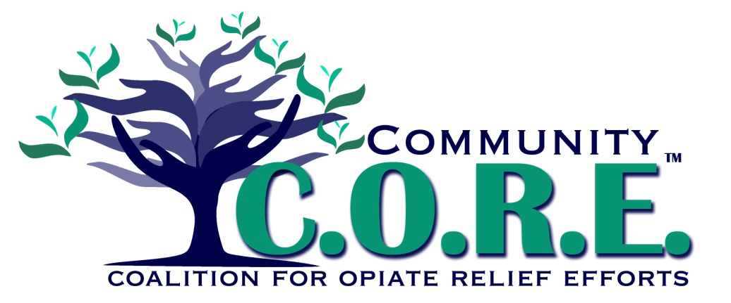**Prevention / Education Team**

Only 32% of youth report knowing how to plan ahead and make choices

**Logan County youth report having only 19 of 40 assets in their lives. (SI Survey 2014)**

41% of Logan Co youth can resist negative peer pressure and dangerous situations

**Opiate abuse is negatively impacting Logan County**

Local home health agencies have inconsistent safe disposal practice recommendations for patients/families

**Problem**

**Logan County residents are not using available drug disposal opportunities**

Logan County residents are unaware of sites to dispose of unused opiate medications

**Risk Factors**

**Local Conditions**