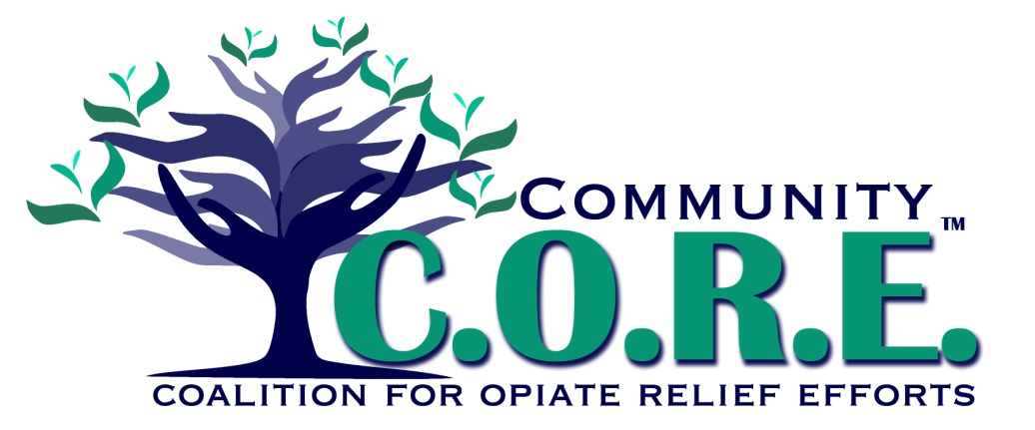**Medical / Harm Reduction Team**

Use of OARRS by prescribers is not sufficiently used to be able to track opiate prescriptions between providers

**Prescription opiates are accessible in the community**

Opiate prescribers do not employ common protocols or best practices

Comprehensive protection measures are not in place to prevent the spread of HEPC and other blood diseases stemming from known opiate users. Systems are not in place to build protection measures to prevent HEPC and other blood diseases from current opiate users.

**Lack of capacity to manage the risk of harm to the community associated with opiate use to the community**

**Opiate abuse is negatively impacting Logan County**

No follow up for patients receiving Narcan

Doctors, service providers and in-home caregivers are not cross system trained to adequately deal with babies born with Neonatal Abstinence Syndrome (NAS)

**Problem**

**Lack of standard infrastructure between Medical and Mental /Behavioral Health systems**

Medical community not connected to pain management and mental /behavioral health to manage chronic pain

Non-prescribers are not equipped to educate patients about opiate use.

Care is not being given to patients while waiting to get into treatment access immediate assistance

**Risk Factors**

**Local Conditions**