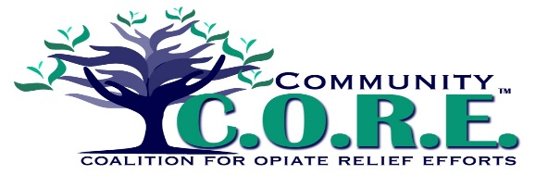
PREVENTION/EDUCATION Team
Drug Disposal LOGIC MODEL – developed 6/8/2016; updated semi-annually

Problem Root Causes Local Conditions & Data
(Specific, identifiable, actionable)
Prescription Drug Misuse
Availability
Inconsistent disposal practices
Data: Drug disposal opportunities are being under-utilized.
Data: 70.4 lbs. of medication was collected in 2014.
- 54 lbs. in 2015
- 110.4 in 2016** engagement began here**
- 60.6 in April 2017
Logan County residents are unaware of sites to dispose of unused opiate medications.

Data: Logan County residents are not disposing of unused opiate medication.
Data: 17.22 opioid doses were dispensed per capita
(OARRS Q1 2016)

Local Home Health Care agencies have inconsistent safe disposal practices/recommendations to clients/family members.
Community members are unaware of safe disposal practices.

Awareness of disposal sites

